Test Case: tc002_SPX_Dev5_Crear_Requisicion_Spot_Con_FAD_Tipo_Cobro_CC
Step 1 - Enter username and password and click to button Enter : Credentials Entered
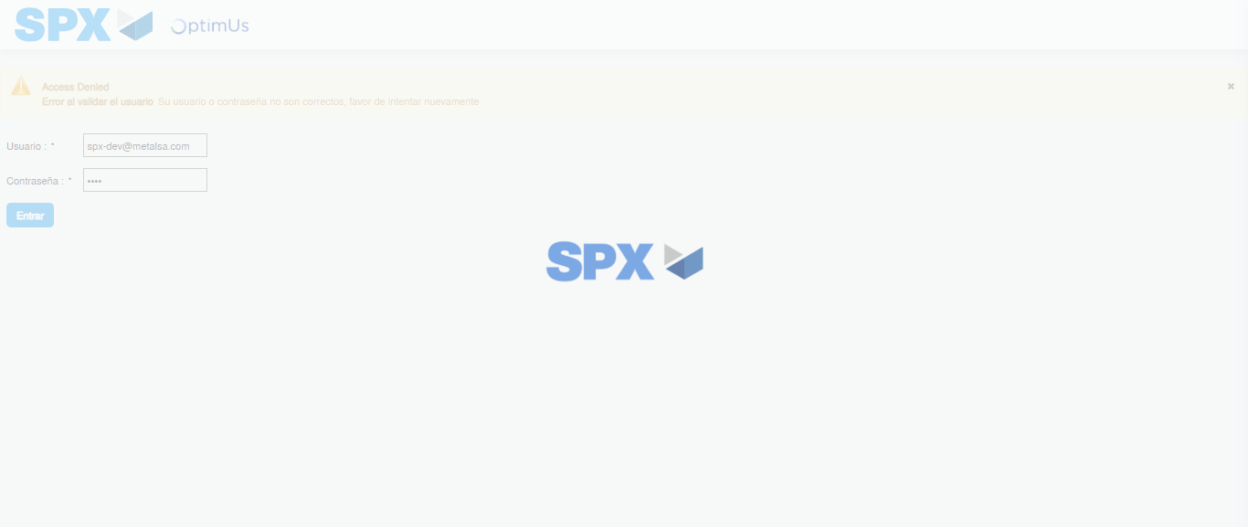Image file-name: QC_Testing-tc002_SPX_Dev5_Crear_Requisicion_Spot_Con_FAD_Tipo_Cobro_CC-1785343572053

Step 2 - Select to UEN and Access to Spot Buy Requisitions : UEN Correctly selected and Correct access
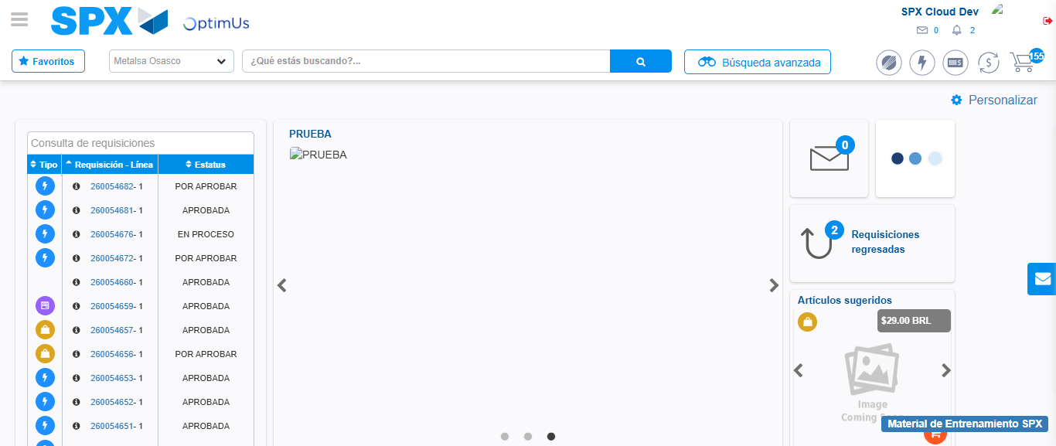Image file-name: QC_Testing-tc002_SPX_Dev5_Crear_Requisicion_Spot_Con_FAD_Tipo_Cobro_CC-1785343597296

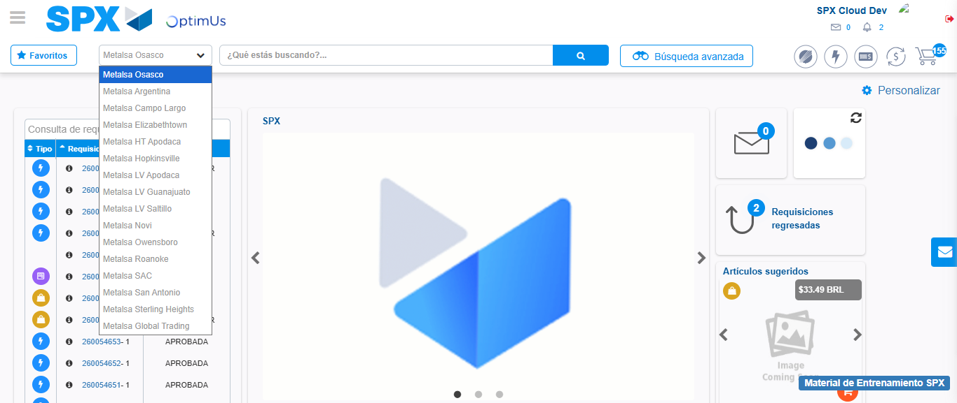Image file-name: QC_Testing-tc002_SPX_Dev5_Crear_Requisicion_Spot_Con_FAD_Tipo_Cobro_CC-1785343599869

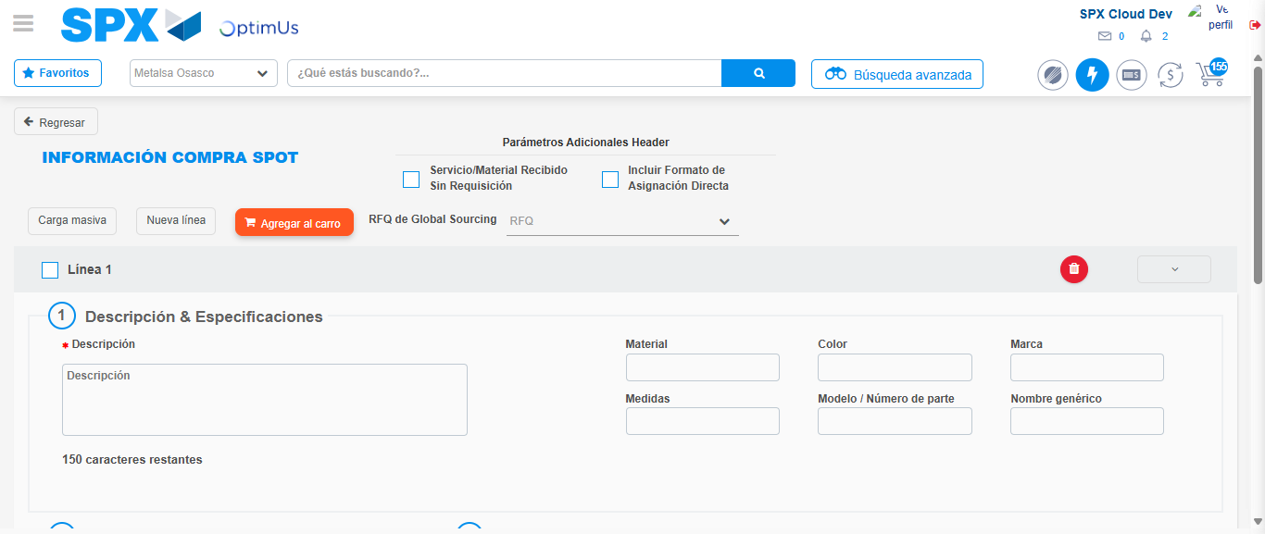Image file-name: QC_Testing-tc002_SPX_Dev5_Crear_Requisicion_Spot_Con_FAD_Tipo_Cobro_CC-1785343624014

Step 3 - Add FAD to Requisition: FAD Successfully Added
Image file-name: QC_Testing-tc002_SPX_Dev5_Crear_Requisicion_Spot_Con_FAD_Tipo_Cobro_CC-1785343624241

Image file-name: QC_Testing-tc002_SPX_Dev5_Crear_Requisicion_Spot_Con_FAD_Tipo_Cobro_CC-1785343624451

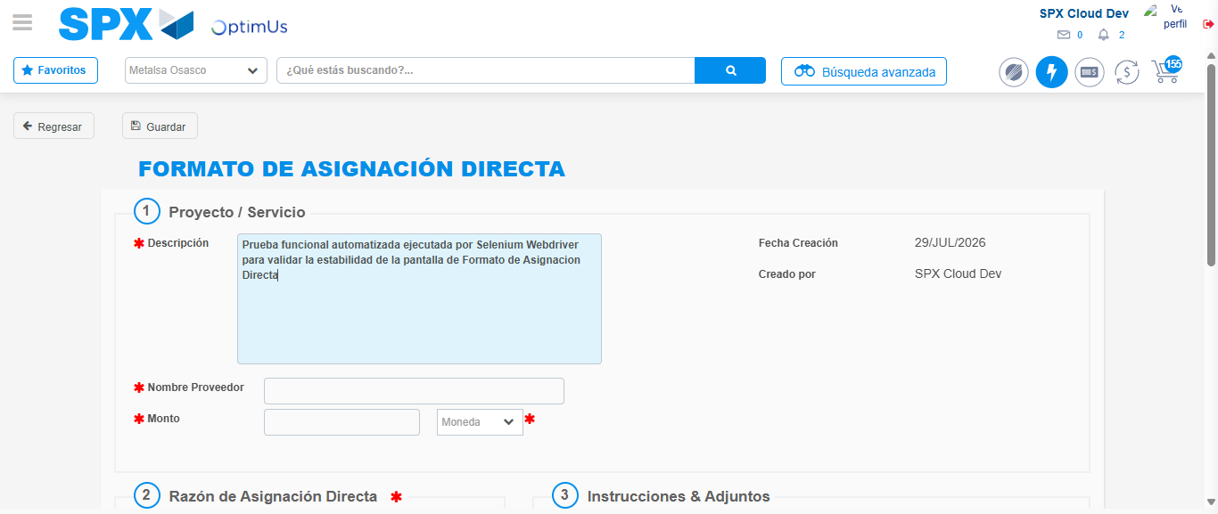Image file-name: QC_Testing-tc002_SPX_Dev5_Crear_Requisicion_Spot_Con_FAD_Tipo_Cobro_CC-1785343627185

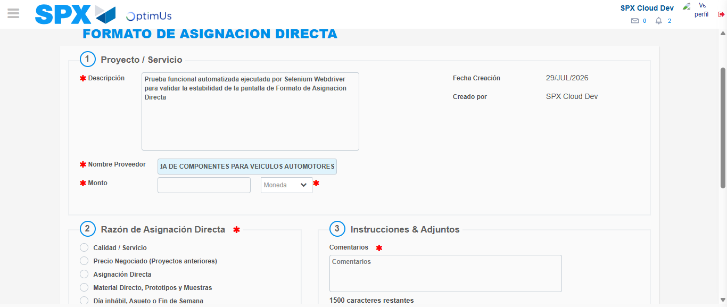Image file-name: QC_Testing-tc002_SPX_Dev5_Crear_Requisicion_Spot_Con_FAD_Tipo_Cobro_CC-1785343636068

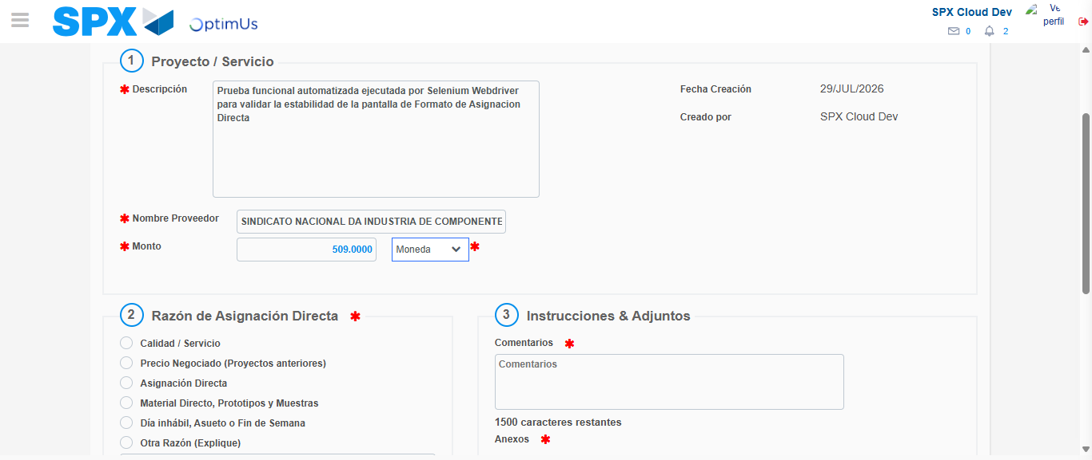Image file-name: QC_Testing-tc002_SPX_Dev5_Crear_Requisicion_Spot_Con_FAD_Tipo_Cobro_CC-1785343636439

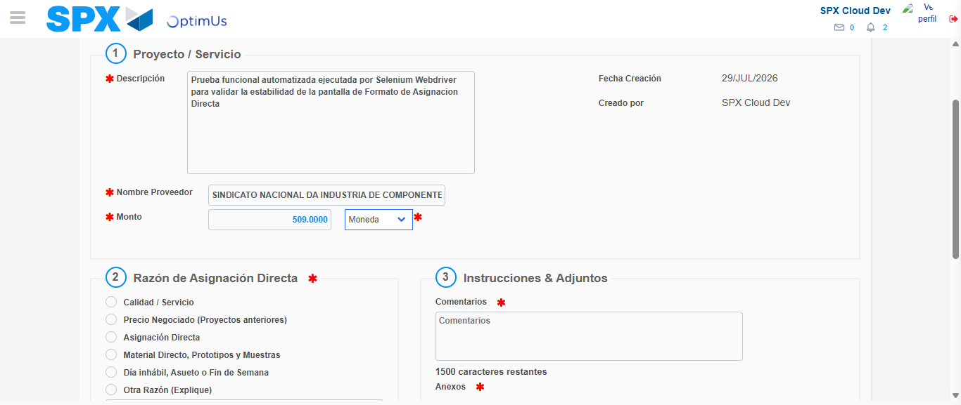Image file-name: QC_Testing-tc002_SPX_Dev5_Crear_Requisicion_Spot_Con_FAD_Tipo_Cobro_CC-1785343636638

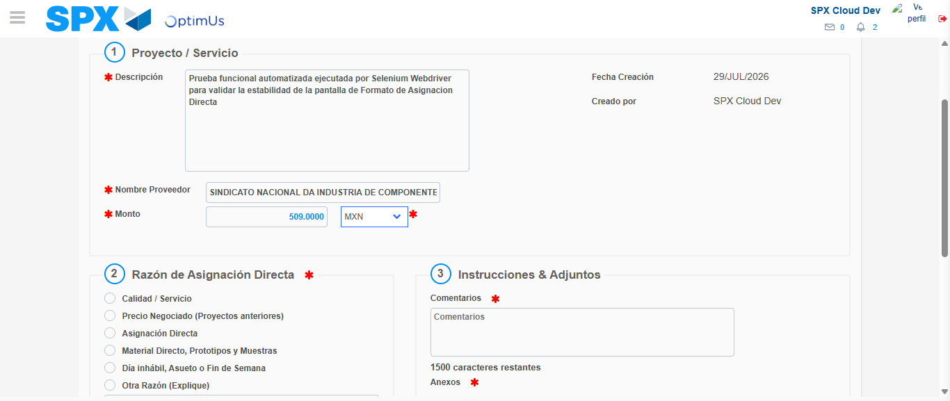Image file-name: QC_Testing-tc002_SPX_Dev5_Crear_Requisicion_Spot_Con_FAD_Tipo_Cobro_CC-1785343636984

Image file-name: QC_Testing-tc002_SPX_Dev5_Crear_Requisicion_Spot_Con_FAD_Tipo_Cobro_CC-1785343637203

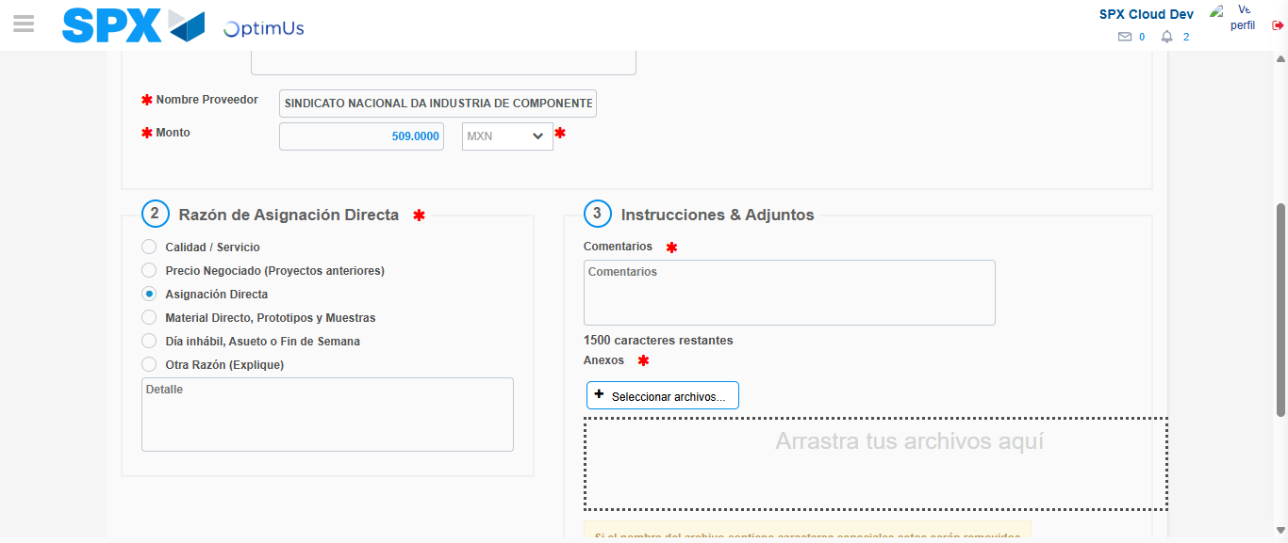Image file-name: QC_Testing-tc002_SPX_Dev5_Crear_Requisicion_Spot_Con_FAD_Tipo_Cobro_CC-1785343638001

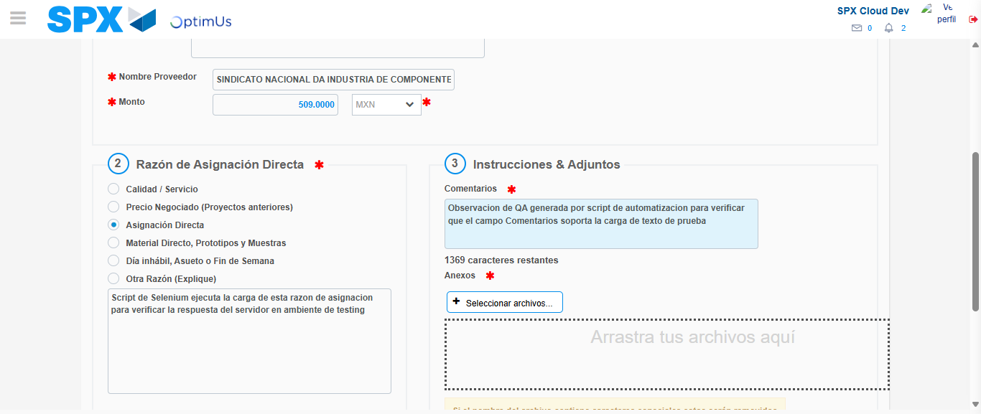Image file-name: QC_Testing-tc002_SPX_Dev5_Crear_Requisicion_Spot_Con_FAD_Tipo_Cobro_CC-1785343648987

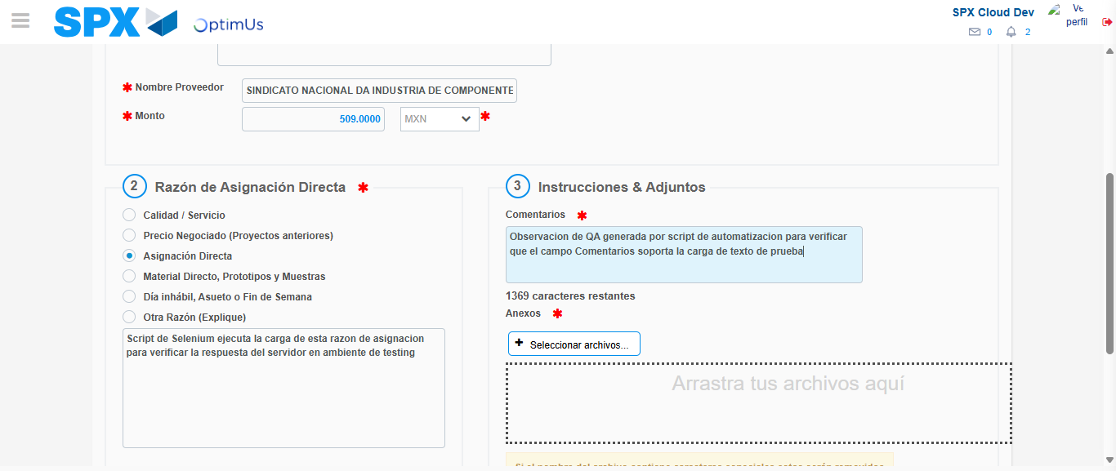Image file-name: QC_Testing-tc002_SPX_Dev5_Crear_Requisicion_Spot_Con_FAD_Tipo_Cobro_CC-1785343649601

Step 4 - Data Capture Spot Buy Requisition: Data captured correctly
Image file-name: QC_Testing-tc002_SPX_Dev5_Crear_Requisicion_Spot_Con_FAD_Tipo_Cobro_CC-1785343624241

Image file-name: QC_Testing-tc002_SPX_Dev5_Crear_Requisicion_Spot_Con_FAD_Tipo_Cobro_CC-1785343624451

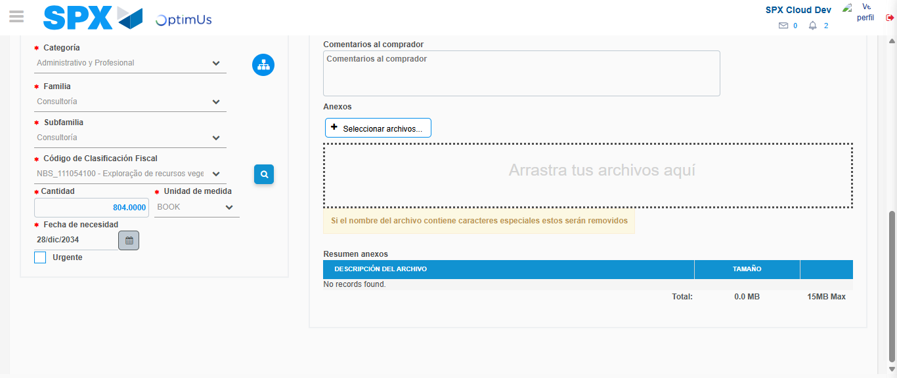Image file-name: QC_Testing-tc002_SPX_Dev5_Crear_Requisicion_Spot_Con_FAD_Tipo_Cobro_CC-1785343665341

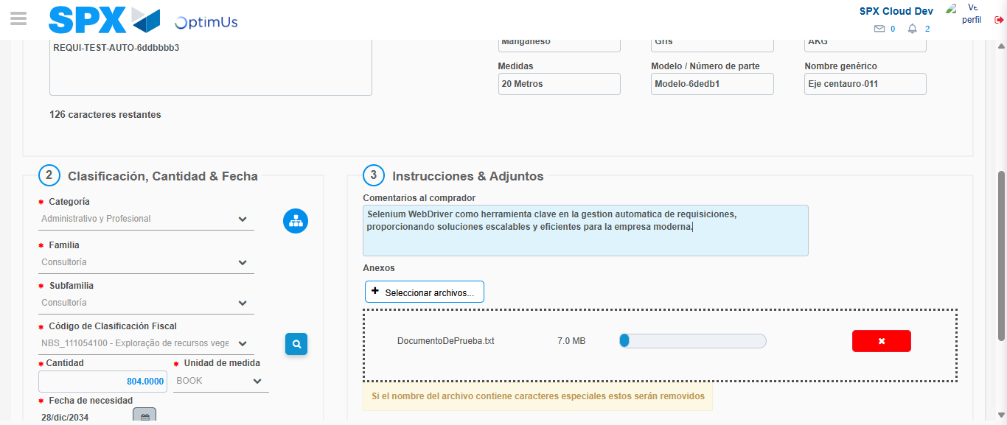Image file-name: QC_Testing-tc002_SPX_Dev5_Crear_Requisicion_Spot_Con_FAD_Tipo_Cobro_CC-1785343666093

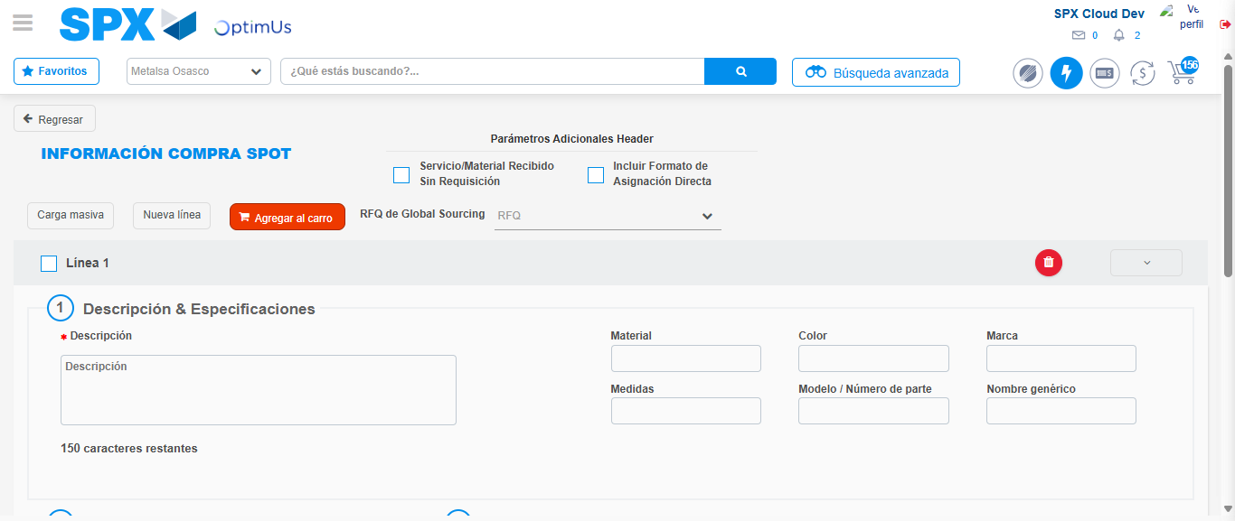Image file-name: QC_Testing-tc002_SPX_Dev5_Crear_Requisicion_Spot_Con_FAD_Tipo_Cobro_CC-1785343678717

Step 8 - Return to Main Page SPX : Return to Main Page SPX
Image file-name: QC_Testing-tc002_SPX_Dev5_Crear_Requisicion_Spot_Con_FAD_Tipo_Cobro_CC-1785343597296

Image file-name: QC_Testing-tc002_SPX_Dev5_Crear_Requisicion_Spot_Con_FAD_Tipo_Cobro_CC-1785343599869

Image file-name: QC_Testing-tc002_SPX_Dev5_Crear_Requisicion_Spot_Con_FAD_Tipo_Cobro_CC-1785343624014

Image file-name: QC_Testing-tc002_SPX_Dev5_Crear_Requisicion_Spot_Con_FAD_Tipo_Cobro_CC-1785343680919

Image file-name: QC_Testing-tc002_SPX_Dev5_Crear_Requisicion_Spot_Con_FAD_Tipo_Cobro_CC-1785343681082

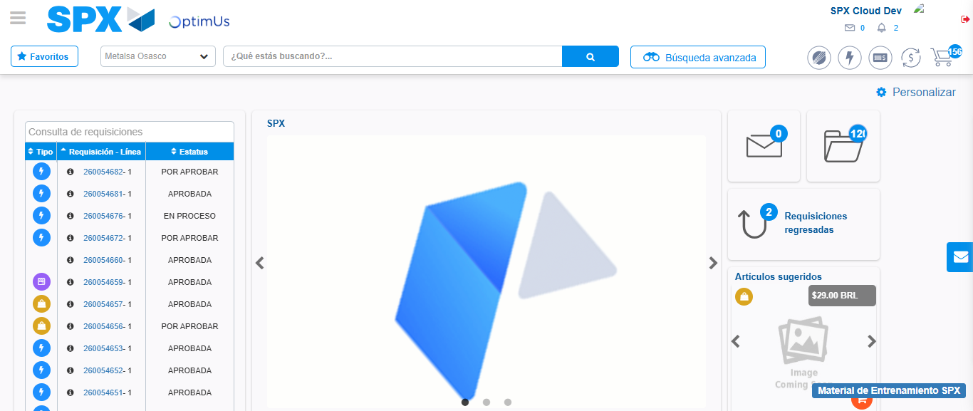Image file-name: QC_Testing-tc002_SPX_Dev5_Crear_Requisicion_Spot_Con_FAD_Tipo_Cobro_CC-1785343702107

Step 9 - Log Out : Log Out SPX
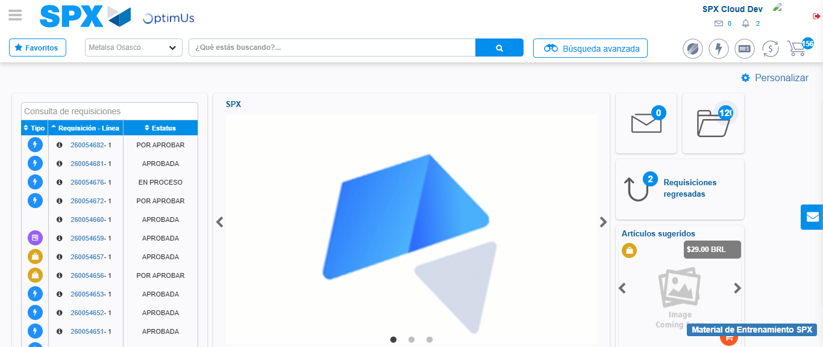Image file-name: QC_Testing-tc002_SPX_Dev5_Crear_Requisicion_Spot_Con_FAD_Tipo_Cobro_CC-1785343702408

